**Name Collin Easley Partners: ________________________________**

**Python Activity 1: Introduction to Python**

|  |
| --- |
| **Learning Objectives**  Students will be able to:  *Content:*   * Explain how to display data in Python * Explain how to create a comment in Python * Determine the difference between a *string literal* and a *number*   *Process:*   * Create **print** statements in Python * Create *Python* code that displays results to calculated addition facts * Discuss problems and programs with all group members   **Prior Knowledge**   * Be able to input and execute Python code using the Python IDE |

**Critical Thinking Questions:**



1. Enter the Python program shown above. What does it do?

Displays Go!

|  |
| --- |
| **FYI:** A **"string literal"** is a sequence of characters surrounded by double quotation marks (" "). |

1. Type and execute following code. What output is produced? Indicate if there is a problem.
   1. print(“Hello, my name is Pat!”) displays Hello, my name is Pat!
   2. print(Hello, my name is Pat) Invalid syntax there is no quotation marks
   3. print(“Hello.\nMy name is Pat”) Hello.

My name is Pat

1. What caused the different output format for samples “a” and “c” in question 2?

A had quotation marks

4. What do you think the following Python statements output? Enter the statements in the interactive mode of the Python interpreter to verify your answers.

* 1. print(2+5) 7
  2. print(2*5) 10
  3. print(“2+5”) 2+5
  4. print(“Age:”,20) Age: 20

1. Examine the output for each statement in question 4.
   1. What is the difference in the output for the statements in “a” and “c” of question 4?

A is doing the addition whereas C has a quotation to print the actual statement but not do the operation.

* 1. What caused the difference? One had string literal and one did not.
  2. Which statements contain a *string literal*? C and D
  3. What does the comma (,) do in the print statement in part “d” of question 4? How does it affect the spacing of the output? Puts a space between the different outputs

1. Examine the following code and its output. What do the first three lines of the program do?

They are comments giving information about the code

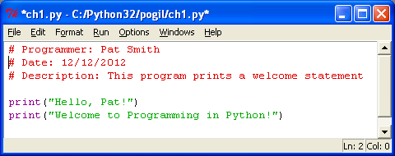

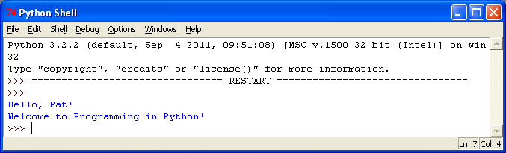

**Output**



1. What would happen if you placed a “#” in front of the code: in the previous program? It makes it a comment instead of a command.

**Application Questions: Use the Python program mode to design and check your work**

1. Create a Python program containing three statements to print the following output. Write the statements below.
2. print("Congratulations!")

print("You just created")

print("your first Phython program")

1. 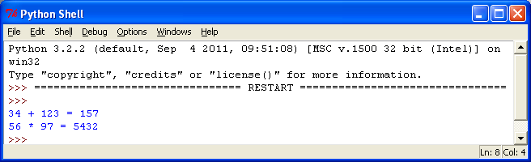Create a Python program containing two statements that prints the output to the right. *Have the program calculate the answers to the two arithmetic problems.*print("34 + 123 =",34+123)

print("56 + 97 =",56+97)